[Keith – here is some text to help get things started – items in yellow are instructions to you and aren’t part of the text]

Home page:
Use HMD colours – purple and mauve, and the HMD logo

Something like this:
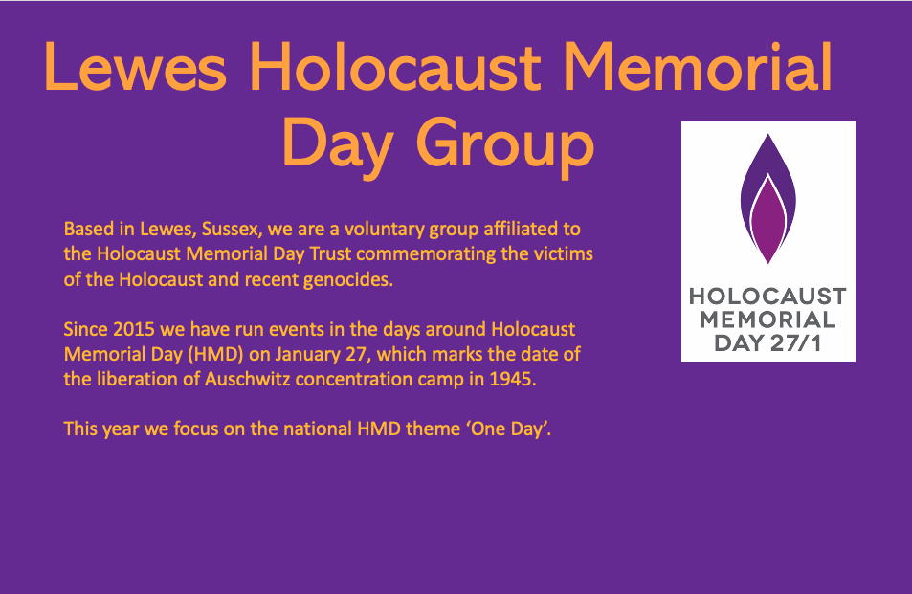

[The text:]
Based in Lewes, Sussex, we are a voluntary group affiliated to the Holocaust Memorial Day Trust commemorating the victims of the Holocaust and recent genocides.
Since 2015 we have run events in the days around Holocaust Memorial Day (HMD) on January 27, which marks the date of the liberation of Auschwitz concentration camp in 1945.
This year we focus on the national HMD theme ‘One Day’.

Follow us on Facebook [facebook logo: embed the link ttps://www.facebook.com/groups/LewesHMhD]

Events for Holocaust Memorial Day, January 2022
[Keith: these are mostly last year’s but serve as dummy entries – would be best if just the headings appear and people can click on those to expand the text]
The national theme this year is One Day: to find out more about this visit the HMD Trust website [embed link: https://www.hmd.org.uk/what-is-holocaust-memorial-day/this-years-theme/]
Please note: because of Covid being so unpredictable we will have to cancel these events in the event of lockdown, or run them online via Zoom. Please keep checking this website for further news.
The organisers would like to thank Lewes Town Council, Lewes District Council and Depot cinema for their generous support.

All January: Lewes Library, Styles Field, Lewes
Lewes Library will be displaying books and DVDs about the Holocaust as well as other genocides and conflicts, for loan.

Saturday 22 January, 14.00-16.00, Lewes Depot, free
Haiku workshop: Acts of Kindness in the Worst of Times
A Haiku is a form of poetry in three lines that focuses on a brief moment in time, and a sense of sudden illumination or enlightenment. Because it is short, anyone can have a go at a haiku. The focus of this on-line workshop will be on acts of kindness that participants would like to celebrate. These can take the form of family memories from the Holocaust, but equally can centre on any remembered occasion when kindness lit up ‘the worst of times’, including our recent Lockdown experiences.
A general discussion will be followed by break-out groups where participants will be able to share and write their memories in intimate groups. A plenary session drawing together our experiences will conclude the afternoon’s event.
To join, email leweshmd1@gmail.com by 21 January, heading your email ‘event1’ and we will send you a Zoom link. Please note that numbers are limited.

Led by Christine Cohen Park.

Thursday 26 January, Cliffe Bridge, Lewes, 6–6.45pm, free
Lantern-lit vigil for Holocaust Memorial Day
Readings, short speeches and moments of quiet contemplation. Bring a lantern and wrap up warm: we’ll keep going in spite of the weather.

Friday 27 January, All Saints Centre, Lewes, 7pm-8.30pm, free
Panel discussion: The Holocaust Legacy
A panel presentation with a range of local speakers from activist groups including Lewes Organisation in Support of Refugees and Asylum Seekers (LOSRAS), the LGBT community, Extinction Rebellion and Amnesty International. Each panellist will provide a short introduction on what lessons his/her organisation can draw from the Holocaust and how they affect values, practices and aims today. Plus Q&A discussion with the audience.

Saturday 28 January, Lewes Depot, Pinwell Road, Lewes 2pm, 8pm, £9 adult/£4 under 25 and those on benefit
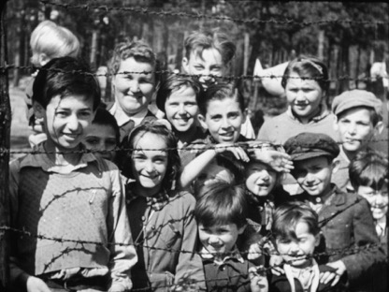
Film: Night will Fall (15) (2014, 75 minutes, in English). £8 adult/£4 under 25 and those on benefit .
When Allied forces liberated the Nazi concentration camps in 1944-45 ,
their terrible discoveries were recorded by army and newsreel cameramen,
revealing for the first time the full horror of what had happened. Directed by André Singer, using material from footage directed by Alfred Hitchcock but unseen for nearly 70 years.
Preceded by an introductory talk and a short film linked to Holocaust Memorial Day.

Sunday 29 January, Lewes Depot, Pinwell Road, Lewes, 2pm, £9 adult/£4 under 25 and those on benefit
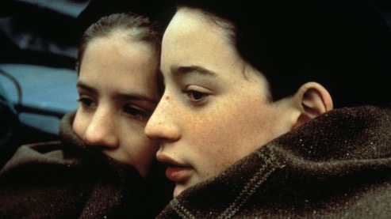
Film: Au revoir les enfants (PG) (1987, 104 minutes, in French with subtitles). Based on wartime events in the childhood of director Louis Malle, this highly acclaimed film beautifully recreates life in 1944 in a boarding school in Nazi-occupied France. Two pupils form a friendship when one of the two realises that the other is a Jewish boy being sheltered in the school by a compassionate priest. “Every scene is masterful” (The Guardian); Winner of the Golden Lion at the Venice Film Awards.

Sunday 29 January, Lewes Depot (Studio), Pinwell Road, Lewes, 8–9pm, free
Readings and music: ‘One Day’
Local poets, musicians and others gather with Adrienne Thomas to reflect on the theme for Holocaust Memorial Day 2022.

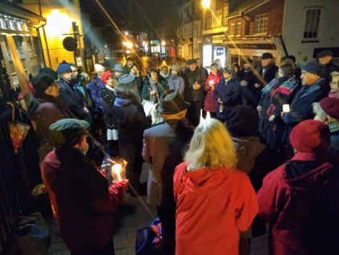
Past years
We started in 2015 on the theme of The Survival of the Human Spirit, focusing on the fate of those deported to Theresienstadt ghetto. Speeches, a klezmer band, poetry reading by students from Priory School and a packed audience in the White Hart Hotel.
On a still winter’s night on January 27 2020 we held a lantern-lit vigil on Cliffe Bridge, with a series of moving readings and short speeches, and read the Kaddish (Jewish prayer for the dead).

In 2016 we held our main event in Lewes Town Hall, with a varied programme of events including music composed in 1940 by Holocaust victim Hans Neumeyer.
We have twice organised exhibitions about refugees in shop windows, the length of Lewes’ long high street.
Workshops on writing haiku and prose, a concert at St John sub Castro featuring choirs, bands and soloists, feature films and a short made by a local film-maker are just some of our activities from past years.
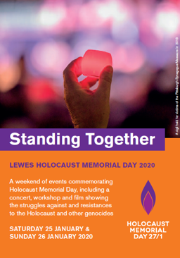
With the struggle against Covid and lockdown, we had to revise plans for January 2021 and make our events online, using Zoom and YouTube. It didn’t deter audiences, though, as we attracted over 100 to our panel discussion and music and readings event, and several hundred to the narrations of family stories by our members and friends. We had to cancel two film events, which we are now carrying over to 2022.

Links and contact
Holocaust Memorial Day Trust [embed link https://www.hmd.org.uk/]

Depot cinema [embed link https://lewesdepot.org/]

Recordings of our events and personal stories on our YouTube channel [YouTube logo: embed the link https://www.youtube.com/channel/UC2lCFTtioyIbtPH1NQZ0QLA]

If you would like to go on our mailing list or be involved in future HMD projects in Lewes, please contact the chairman Tim Locke at leweshmd@gmail.co.uk

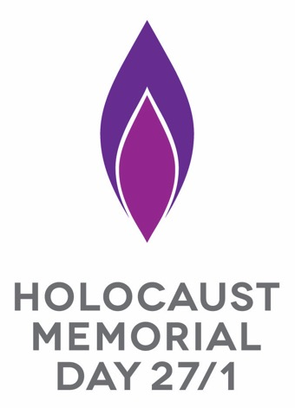

[could put some of these general photos on this page or anywhere on the site:]

